Assignment 2 – Network Security

1. Introduction to Network Security Challenges
Network security refers to the protection of computer networks from unauthorized access, misuse, or attacks. In today's digital world, organizations and individuals rely heavily on computer networks to store, process, and transmit information. Because of this, ensuring the security of these networks has become extremely important. Network security involves policies, procedures, and technologies that help protect data and systems from cyber threats.
One of the major challenges in network security is cyber attacks. Cyber attackers use different techniques such as malware, phishing, ransomware, and denial-of-service (DoS) attacks to damage systems or steal sensitive data. Malware is malicious software that can infect systems and cause data loss or system failure. Phishing attacks trick users into revealing personal information such as passwords or banking details.
Another challenge is unauthorized access. Hackers may attempt to gain access to networks by exploiting system vulnerabilities or weak passwords. Once attackers gain access, they can steal confidential information, modify data, or disrupt services.
Data breaches are also a serious network security challenge. A data breach occurs when sensitive or confidential information is accessed by unauthorized individuals. This can lead to financial loss, reputation damage, and legal consequences for organizations.
The rapid growth of technology has also increased network security challenges. With the use of cloud computing, mobile devices, and remote work environments, networks have become more complex. Each connected device can become a potential entry point for attackers.
Another important issue is human error. Employees may accidentally click on malicious links, download harmful files, or use weak passwords. These mistakes can create vulnerabilities in a network and allow attackers to gain access.
Because of these challenges, organizations must implement strong security measures, continuously monitor their networks, and educate users about cybersecurity risks. Proper network security helps ensure the confidentiality, integrity, and availability of information.
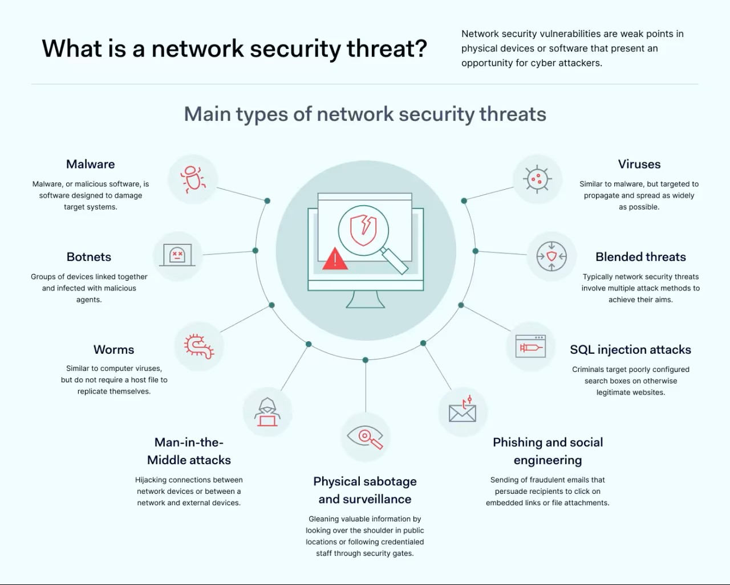

2. Basic Security Measures (Firewalls and VPNs)
To protect networks from security threats, several basic security measures are commonly used. Two of the most important are firewalls and
Virtual Private Networks (VPNs).
A firewall is a security system that monitors and controls incoming and outgoing network traffic based on predefined security rules. It acts
as a barrier between a trusted internal network and untrusted external networks such as the internet. Firewalls can block unauthorized access
while allowing legitimate communication. They help prevent hackers and malicious software from entering the network.
A Virtual Private Network (VPN) is a technology that creates a secure and encrypted connection over the internet. VPNs allow users to safely
access a private network from remote locations. The data transmitted through a VPN is encrypted, which protects it from being intercepted by
attackers.
Together, firewalls and VPNs play an important role in protecting network systems, ensuring secure communication, and reducing the risk of
cyber attacks.
